**Non-Linear Regression Methods and Other Recommendations**

**Model Tuning and choosing parameters**

Machine learning models are parameterized such that there has to be a search for the combination of parameters that will result in the optimal performance of the model. The parameters that define the model architecture are referred to as hyperparameters while the process of exploring a range of values is called hyperparameter tuning. It is important to note the distinction between model parameters and hyperparameters. Unlike hyperparameters, model parameters are learnt during the training phase while setting hyperparameters is exclusive of the training process. Ideally, when hyperparameter tuning is completed, the result is the best parameters for the model. Grid search and random search are two common strategies for tuning hyperparameters.

**Grid Search**

Grid search explores the combination of a grid of parameters such that for every combination of parameters, a model is built and evaluated then the model with the best result selected and its corresponding parameters. While it is computationally expensive, setting up a grid search is quite easy.

**Random Search**

As opposed to grid search, random search randomly combines parameter values in the grid to build and evaluate models. It does not sequentially combine all parameters as in grid search instead, it allows for a quick exploration of the entire action space to reach optimal values.

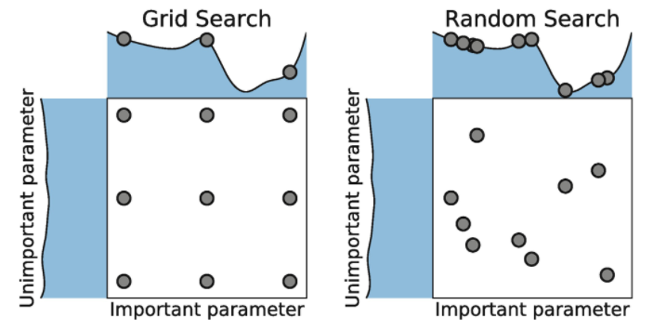

**Data splitting, resampling and cross validation strategy**

Data splitting in data science involves setting aside a portion of the dataset for testing (out of sample or hold-out) and evaluating the performance of the model to provide unbiased results while the rest is used in fitting the model. The proportion of division is solely based on choice and sometimes, the size of the dataset. However a common practice is to split the dataset into training, validation or dev and testing sets where the validation set is used to tune the hyperparameters to select the best values for the model. Resampling involves repeatedly selecting samples from the original dataset and using these samples to obtain more information about the model. This can create different samples of the training set and another for evaluation. Cross validation is a method used to generalise and prevent overfitting in machine learning